Computer Systems
CFGS DAW



SECOND term
Assessable Activity

Álvaro Maceda
a.macedaarranz@edu.gva.es
2022/2023
Version:230323.2001
License


Attribution - NonCommercial - ShareAlike (by-nc-sa): No commercial use of the original work or any derivative works is permitted, distribution of which must be under a license equal to that governing the original work.

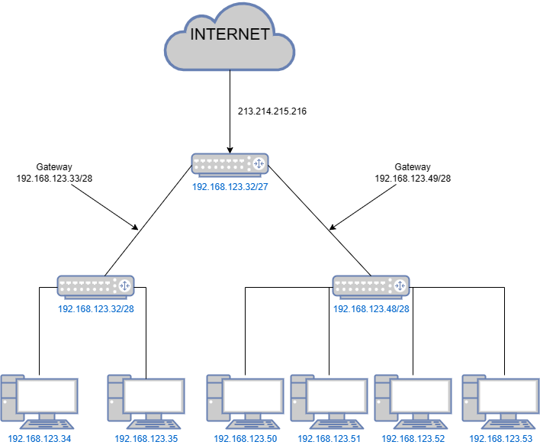
Second Term: Assessable activity

Exercise 1

Network topology

Network addresses
Network | Address
Network A – Start | 192.168.123.32/28
Network A – Finish | 192.168.123.47/28
Network B – Start | 192.168.123.48/28
Network B – Finish | 192.168.123.63/28

IP adresses
Network A
Device | IP
Device 1 | 192.168.123.34/28
Device 2 | 192.168.123.35/28
Router | 192.168.123.32/28
Broadcast | 192.168.123.47/28
Gateway: (192.168.123.33/28)
Network B
Device | IP
Device 1 | 192.168.123.50/28
Device 2 | 192.168.123.51/28
Device 3 | 192.168.123.52/28
Device 4 | 192.168.123.53/28
Router | 192.168.123.48/28
Gateway: (192.168.123.49/28)

Exercise 2

Part 1

Content of files
File name: dockerfile
Contents:
FROM ubuntu:22.04
RUN apt-get update
RUN apt-get install -y openssh-server
RUN apt-get install openssl
RUN useradd -m -p "(openssl passwd -1 user1server)" user1
RUN useradd -m -p "(openssl passwd -1 user2server)" user2
RUN mkdir /var/run/sshd
RUN touch /etc/ssh/sshd_config.d/port.conf
RUN echo "Port33" > /etc/ssh/sshd_config.d/port.conf
CMD["/usr/sbin/sshd", "-D", "-o", "ListenAddres=0,0,0,0"
File name: port.conf
Contents:
Port 33

Command(s) to build the image
docker build -t server exercise3-server . #for build image
docker create –name server exercise3-server #for create container
docker start server #for start container
docker inspect server #for know IPAddress, in this case, 172.18.0.2
ssh user1@172.18.0.2 -p 33 #for access the ssh with the port 33

Part 2

Commands to launch the containers
docker create -p 22 --name server ex3-server
docker create -t -i --name client ex3-client
docker start server
docker start client

Commands to test the service from the docker client
Docker exec client /bin/bash #for execute container
ssh user1@172.18.0.2 #for connect with server

Command(s) to test the service from your host
(write the commands here)

docker network create --driver bridge --subnet 192.168.0.0/16 server-client

